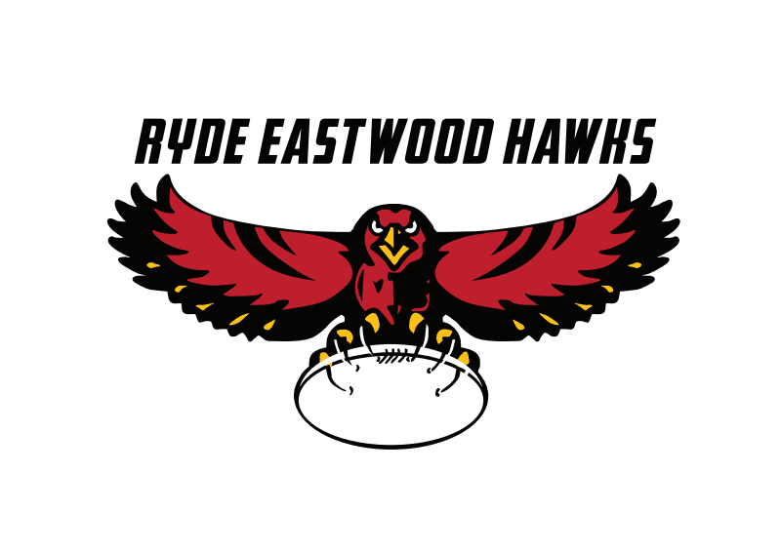
Ryde Eastwood Touch Football Association Inc.
Board nomination form – 2024/2025
Please accept the completion of this form as notification of my willingness to serve as a board member for Ryde Eastwood Touch Football Association Incorporated for the 2022/2023 period.
Furthermore I accept the nomination for the position(s) of:
President: Y / N – (Circle Y to indicate willingness to stand as President. Circle N to decline.)
Secretary: Y / N – (Circle Y to indicate willingness to stand as Secretary. Circle N to decline.)
Treasurer: Y / N – (Circle Y to indicate willingness to stand as Treasurer. Circle N to decline.)
Nominee: _________________________________ Telephone No.: ____________________
Email: ____________________________________
Signature of nominee: ________________________________ Date: _________________
Class of membership: Affiliated Senior Team Delegate ( ), Affiliated Junior Team Delegate ( )
Life Member ( ), Association Patron ( ), Nominated Member ( ),
Other (please specify) - _____________________________

Proposer: _____________________ Telephone No.: ____________________ Email: _________________
Class of membership: _________________________ (Choose from list above)
Signature of proposer: _______________________ Date: ____________________

Seconder: _____________________ Telephone No.: ___________________ Email: _________________
Class of membership: _________________________ (Choose from list above)
Signature of seconder: _______________________ Date: ____________________
__________________________________________________________________________________________
Admin use
Date received: ______________________ Received by: ____________________________
Nominee status confirmed: (Y/N) - Proposer status confirmed: (Y/N) - Seconder status confirmed: (Y/N)

Date advice sent to above parties regarding the status of the application: _____________
Advice sent by: ____________________________

